Assignment 2: Dashboard
Team members: Kojic Marko, Kojic Dimitrije – MIM252
Public view: https://koyara.netlify.app/

Business Description
Business requirement for the dashboard
The dashboard is a strategic management tool designed to help Universal Music Group (UMG) navigate the shifting landscape of global music consumption. By converting complex streaming and physical sales data into visual trends, it enables leadership to reallocate marketing budgets and A&R (Artist & Repertoire) resources toward high-growth genres and regions.

Business context:
Universal Music Group is a global leader in music-based entertainment. The company manages a vast catalog of artists and labels, generating revenue through the release of Singles and Albums across various formats (Digital Streaming, Physical, and Downloads).

Segments (Release Types):
Single: Individual track releases, often used to build momentum and drive streaming volume.
Album: Full-length collections, typically driving higher profit margins and deeper fan engagement.

Description of the business problem(s):
Consumer preferences are shifting rapidly; legacy genres are seeing a decline in market share while emerging genres (e.g., K-Pop, Afrobeats, or Latin Synth) are surging. UMG lacks a centralized high-level view to quickly identify which genres are losing steam and which are becoming "cash cows." Without this, the company risks over-investing in declining markets and missing windows of opportunity in growth regions.

Dashboard goals:
Identify Genre Trends: Visualize the rise and fall of genre popularity over time.
Optimize Portfolio Mix: Determine the ideal balance between Single and Album releases.
Regional Performance: Pinpoint which geographic regions are driving the most revenue for specific genres.
Investor Transparency: Provide a clear, data-backed narrative of UMG’s market adaptation to stakeholders.

Key questions that the dashboard should answer:
Which genres are experiencing the highest year-over-year (YoY) growth in sales?
How does the revenue split between Singles and Albums differ across genres?
In which regions is a specific genre underperforming compared to the global average?
Which "Legacy" genres are maintaining stable revenue versus those in sharp decline?

Target audience:
Top Managers (C-Suite): To inform long-term acquisition and signing strategies.
Investors: To demonstrate UMG’s ability to capture shifting market demands.
Global Marketing Directors: To adjust regional campaign spends.

2. Data Preparation
Data:
The dataset integrates two primary sources of music commerce data:
Release Metadata:
Release ID, Artist Name, Genre, Release Type, Release Year
Genre: Pop, Rock, Hip-Hop, R&B, Latin, Country, Electronic, etc.
Type: Album, Single
Year: 2018–2025
Global Sales Data:
Release ID, Region, Sales Volume, Revenue (USD), Period (Month/Year)
Region: North America, Europe, LATAM, APAC, Africa

Data descriptive statistics
The Release Metadata dataset contains approximately 1,200 unique releases.
The distribution of releases by type shows:
Singles represent 70% of the catalog (reflecting the "streaming-first" strategy).
Albums represent 30% of the catalog.

By Genre (Volume):
Pop and Hip-Hop remain the largest categories (combined 60%).
Latin and "Global/Emerging" genres have seen a 40% increase in volume since 2022.

Revenue Distribution:
Average Revenue per Release: $12,500.
Distribution: Highly skewed ("Power Law"). A small percentage of "Superstars" generate 80% of the revenue, while "Long Tail" artists generate steady but smaller amounts.
Zero Values: Found in upcoming releases (pre-release phase) or niche catalog items with no activity in specific months; these are kept to show market reach and "dead" inventory.

Revenue Trends: Revenue peaked in 2024 due to a surge in subscription streaming prices and high-profile stadium tour tie-in releases. 2025 shows a shift toward "Niche-to-Mass" genres, where smaller genres are collectively taking share from traditional "Pop."
Data cleaning and transformations performed
The data underwent the following checks:
Genre Standardization: Inconsistent labels (e.g., "Hip Hop" vs "Hip-Hop") were unified.
Currency Conversion: All regional sales were converted to USD based on the historical exchange rate of the transaction month.
Categorization: Releases were tagged as "New" (within 12 months) or "Catalog" (older than 12 months) to help managers distinguish between current hits and steady earners.
Aggregation: Revenue was aggregated by Genre and Region to allow for the "Drill-down" functionality in the dashboard filters.

3. Dashboard Description

KPI Cards (Top Row)
Five strategic indicators provide an immediate performance health check for executive leadership and investors.
KPI | Field | Aggregation | Business Meaning
Total Revenue | revenue_usd | SUM | Total gross sales across all regions and formats.
YoY Growth | revenue_usd | % Change | Momentum indicator comparing current year to the previous year.
Top Genre | genre | MAX (Revenue) | Identifies the most dominant musical category in the current portfolio.
Top Region | region | MAX (Revenue) | Identifies the geographic territory driving the most value.
Single : Album | release_type | Ratio | Revenue balance between high-frequency singles and high-margin albums.

Charts:
Chart 1 — Genre Revenue Trends (Line Chart)
Visualizes the lifecycle and popularity shifts of music genres from 2020–2024.
Dimension: Year; Measure: SUM(Revenue); Color: Genre.
Business Value: Identifies "breakout" genres (e.g., the massive spike in Latin in 2022) and declining legacy genres to guide A&R investment.

Chart 2 — Genre Market Share (Donut Chart)
Provides a proportional breakdown of the total revenue pie by genre.
Dimension: Genre; Measure: SUM(Revenue).
Business Value: Shows portfolio diversification. A balanced donut indicates lower risk, while dominance by one genre suggests a need for diversification.

Chart 3 — Revenue by Region (Horizontal Bar)
Ranks the performance of UMG’s four primary global territories.
Dimension: Region; Measure: SUM(Revenue).
Business Value: Answers where the company should focus its physical distribution and localized marketing efforts.

Chart 4 — Single vs Album by Genre (Stacked Bar)
Compares the revenue contribution of release formats within each genre.
Dimension: Genre; Measure: SUM(Revenue); Stack: Release Type.
Business Value: Reveals consumer behavior per genre (e.g., if Hip-Hop is driven by Singles while Rock is driven by Albums), allowing for format-specific production strategies.

Chart 5 — Top Releases (Data Table)
A granular list of the highest-grossing individual assets (Singles/Albums).
Columns: Release Name, Genre, Type, Year, Region, Revenue.
Business Value: Allows managers to drill down from high-level trends to specific "Superstar" assets driving the numbers.

Filters (5 Selectors)
Filter | Field | Type
Year | release_year | Dropdown (Single/Multi)
Genre | genre | Multi-select list
Region | region | Multi-select list
Release Type | type | Multi-select list (Album/Single)
Search | release_name | Text input (contains)

Alarm & trigger concepts (not automated)
YoY growth < 0% — declining slice; review genre/region investment.
Region revenue drop > 20% YoY — investigate distribution and marketing.
Genre share < 5% — consider reduced focus unless strategic.
Growth > 15% YoY — candidate for increased marketing and A&R.
Album revenue far below singles in a genre — revisit release strategy for that genre.

4. Created Dashboard
Link:
https://koyara.netlify.app/

Screenshots:
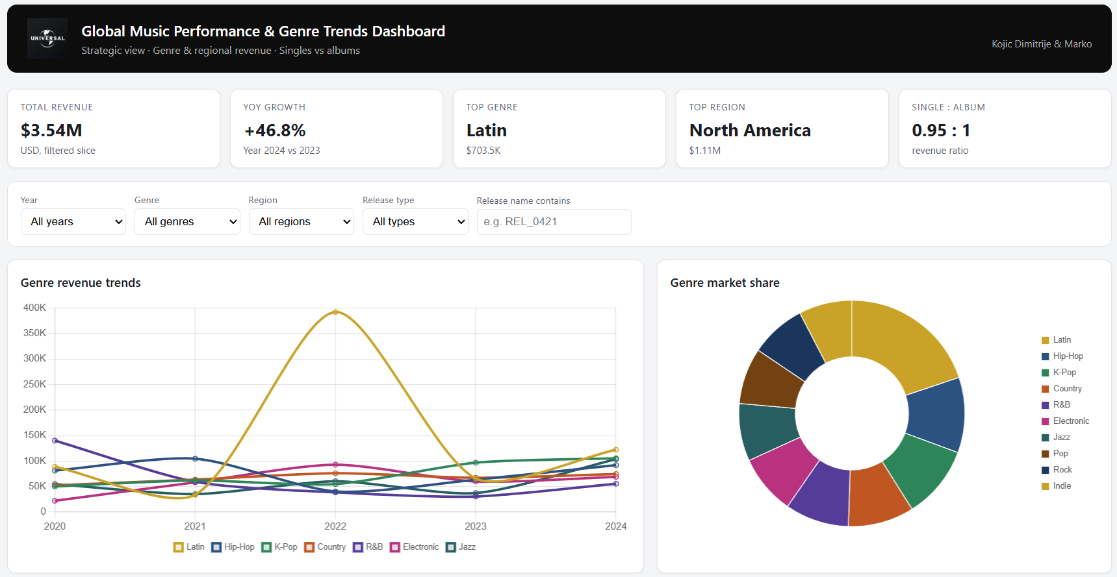
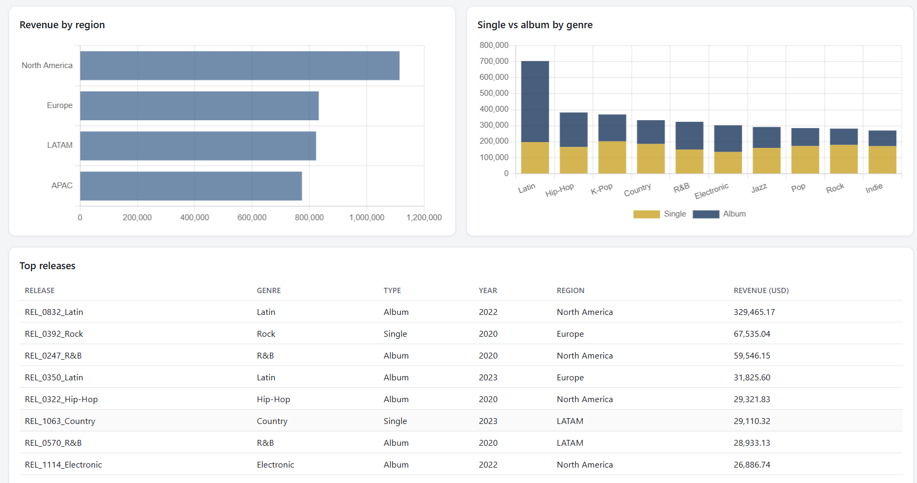

5. Dashboard Peer Review
Reviewer: Kojic Marko, Dimitrije
Dashboard being reviewed: SkillCamp VR Training Performance Dashboard
Dashboard being reviewed created by: Junis

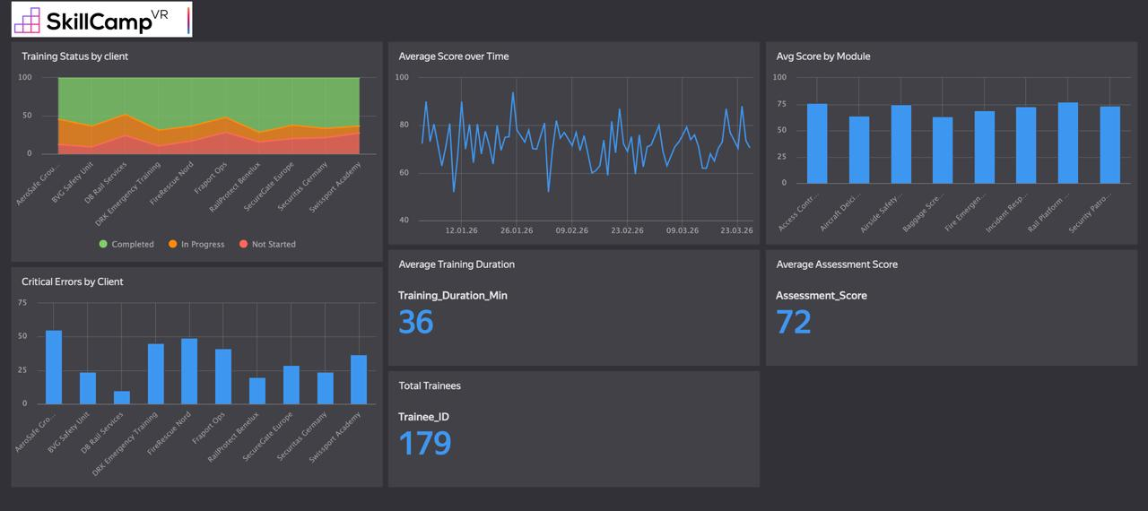

1. Summary & First Impressions (The "What")
This dashboard is designed to monitor VR training performance and engagement across different clients, focusing on metrics such as training completion status, assessment scores, error rates, and training duration.
The primary user appears to be a training manager, L&D specialist, or operations lead responsible for evaluating training effectiveness and identifying performance gaps across clients.
Initial impression:
The dashboard is well-structured and logically segmented, with clear grouping of KPIs and charts. Key metrics (e.g., average score, duration, total trainees) are prominently displayed. However, the layout feels slightly dense, and some visual elements compete for attention, which can reduce immediate clarity.

2. Analysis of Strengths ("What Works")
1. Clear KPI Highlighting
The use of large numeric cards for:
Average Training Duration (36 min)
Average Assessment Score (72)
Total Trainees (179)
is highly effective. These KPIs are immediately visible and digestible, supporting quick executive-level insights.

2. Comprehensive Coverage of Metrics
The dashboard successfully integrates multiple perspectives:
Performance over time (line chart)
Client comparison (bar charts)
Module-level insights
Error tracking
This creates a multi-dimensional view, enabling users to analyze both macro trends and granular breakdowns.

3. Consistent Chart Types for Comparisons
Bar charts are consistently used for:
Avg Score by Module
Critical Errors by Client
This consistency improves cognitive efficiency, allowing users to quickly interpret comparisons without re-learning visual patterns.

3. Constructive Critique & Recommendations ("What Could Be Improved")
A. Clarity & Usability
Issue:
The dashboard feels visually crowded, especially in the top row where multiple charts compete for attention.
Recommendation:
Introduce more spacing or grouping (e.g., separate "Performance" vs "Engagement" sections).
Consider using collapsible sections or tabs if this is an interactive dashboard.
Reduce the number of categories shown on X-axes (client names are hard to read).

B. Strategic Relevance
Issue:
While many metrics are shown, it is not immediately clear what the key business objective is (e.g., improving completion rates vs reducing errors).
Recommendation:
Add a headline insight or goal indicator, such as:
“Training Completion Rate Target: 85%”
“Error Reduction Goal: -20% QoQ”
Highlight underperforming clients/modules with conditional formatting.

C. Data Storytelling & Context
Issue:
The dashboard presents data but lacks contextual interpretation.
Examples:
Is an average score of 72 good or bad?
Are 36 minutes optimal or too long?
Recommendation:
Add benchmarks or thresholds (e.g., target lines in charts).
Include trend indicators (↑ ↓) for KPIs.
Provide short annotations like:
“Scores declined in mid-February”
“Client X shows highest error rate”

D. Visual Design

Issue 1: Line chart readability (Average Score over Time)
The line chart appears noisy and hard to interpret due to:
High fluctuation
Dense data points
Recommendation:
Apply smoothing (moving average) or reduce granularity.
Highlight key points (peaks/drops).

Issue 2: Gridline prominence
Gridlines across charts are quite visible and add visual clutter.
Recommendation:
Reduce gridline opacity to improve signal-to-noise ratio, allowing data to stand out more clearly.

Final Assessment
The dashboard is functionally strong and data-rich, with solid KPI prioritization and good structural logic. However, it would benefit significantly from:
Improved visual hierarchy
Cleaner design execution

